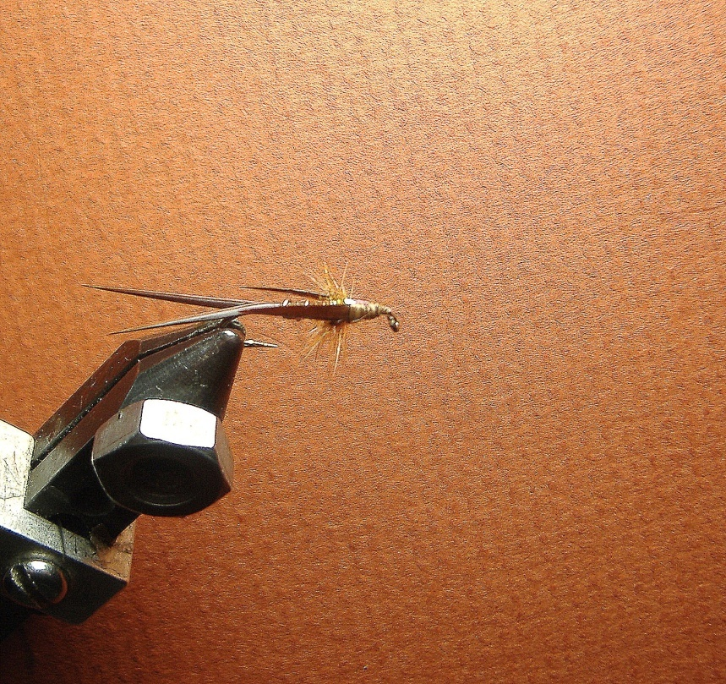

**Materials List**

**Hook: #14 2 XL Long Hook**

**Thread: Brown**

**Tail: Brown Goose Biots**

**Body: Tying Thread**

**Rib: Small Copper Wire**

**Hackle: Brown 12---14**

**Brown Biots Goose Biots**

**Pull Over : Strip of Thin Pearl Flash**