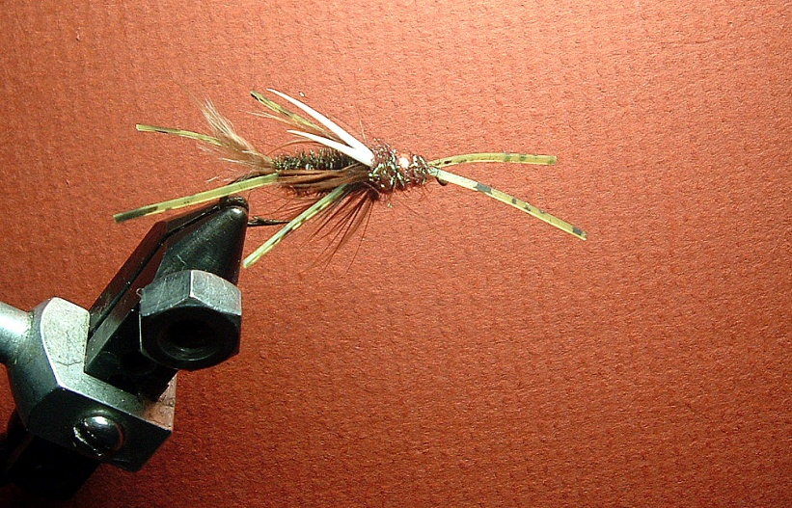

**Materials List**

**Hook: 8—10 2XL TMC/or equivalent nymph hook**

**Thread : 3/0 Black/70 Denier**

**Bead: 5/32 Copper**

**Under body: .020 Lead**

**Antennae: Crazy Legs Olive/Green Flakes**

**Tail: Brown marabou & Crazy Legs**

**Legs: Crazy Legs Olive/Green Flakes**

**Rib: Medium Brassy Copper Wire**

**Body: 7-8 strands of Peacock Hurl**

**Hackle: Dyed Brown Soft Hen Hackle**

**Wing: White Goose Biots**

**Thorax: Peacock Ice Dub**

**Head: Peacock Ice Dub**

**Suggestion: Go to Caddis Fly Shop Tying Videos and call up the Mega Prince. You can watch the fly being tied.**

**Rod**